Office of the General Counsel

Monday, May 15, 2017

VIA EMAIL

Mr. Eugene Quinn
IP Watchdog, Inc.

Dear Mr. Quinn:

Your Freedom of Information Act (FOIA) and/or Privacy Act request was received by the United States Patent and Trademark Office (USPTO) FOIA Office on Friday, May 12, 2017.

Your request has been docketed as “FOIA Request No. F-17-00235.” Any further inquiries regarding your request should include that number. A copy of your request is attached for reference.

In the event your original request was incorrectly addressed, please address all inquiries regarding your request to:

FREEDOM OF INFORMATION ACT (FOIA) OFFICER
United States Patent and Trademark Office
P.O. Box 1450
Alexandria, VA 22313-1450

Or via email to foiarequests@uspto.gov

The Agency expects to send its response to this request no later than Monday, June 12, 2017. You will be notified if it appears that additional time is required. You may check on the status of your request at the Agency’s website: www.uspto.gov, click on “Freedom of Information Act” at the bottom of the page, and then “Check FOIA Request Status.” You will need your request number, shown above, to check on the status of your request.

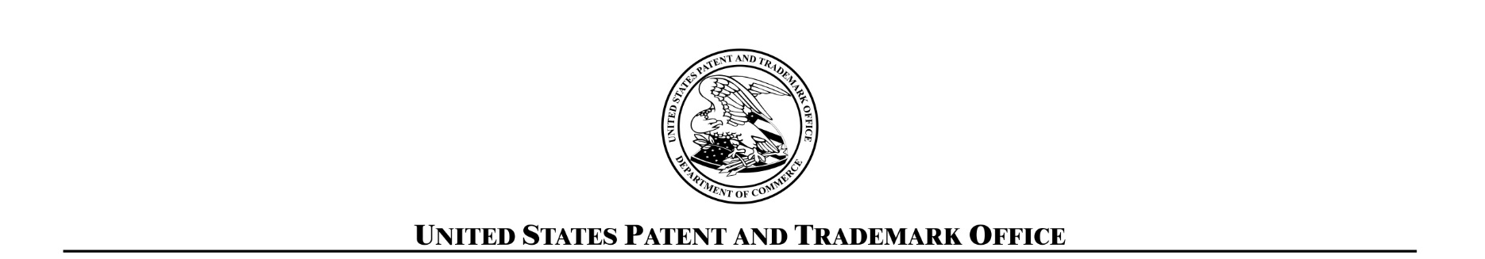
Sincerely,

USPTO FOIA Office

Enclosure

