APPEAL NO. 19-1846
___________________________________________________

UNITED STATES COURT OF APPEALS FOR THE FEDERAL CIRCUIT
___________________________________________________

CONSUMER 2.0, INC. D/B/A RENTLY,

Plaintiff-Appellant,

v.

TENANT TURNER, INC.,

Defendant-Appellee.
__________________________________________________

Appeal from the United States District Court Eastern
District of Virginia, Norfolk Division
Case No. 2:18-cv-00355-RGD-DEM
Judge Robert G. Doumar
__________________________________________________

REPLY BRIEF FOR PLAINTIFF-APPELLANT
___________________________________________________

Rudolph A. Telscher, Jr., rudy.telscher@huschblackwell.com
Kara R. Fussner, kara.fussner@ huschblackwell.com
HUSCH BLACKWELL LLP
190 Carondelet Plaza, Suite 600
St. Louis, MO 63105
314-480-1500 Telephone
314-480-1505 Facsimile

Stephen Z. Vegh
svegh@veghlaw.com
VEGH IP LEGAL
1240 Rosecrans Ave., Suite 120
Manhattan Beach, CA 90266
(310) 980-7440

TABLE OF CONTENTS
Page
TABLE OF CONTENTS ii
TABLE OF AUTHORITIES iii
I. INTRODUCTION 1
II. STATEMENT OF FACTS IN REPLY 2
A. The ‘590 Patent Describes and Claims a Lock Box that Can Recognize and Open In Response to Time-Specified Codes. 3
B. The Prosecution History Reveals Amendments Requiring a Lock Box Capable of Recognizing Time-Specified Codes 6
III. ARGUMENT 9
A. The District Court’s Misunderstanding of the Claimed Invention—Or At Least the Dispute Over the Claimed Invention—Requires Remand 9
B. The ’590 Patent Claims Patent Eligible Subject Matter 14
1. Claim 7 Is Not Directed To an Abstract Idea 15
2. The Claimed Technology-Enabled Lock Box Was Unconventional At The Time Of Filing 20
IV. CONCLUSION 28
CERTIFICATE OF COMPLIANCE 30
CERTIFICATE OF SERVICE 31

TABLE OF AUTHORITIES
Cases
Aatrix Software, Inc. v. Green Shades Software, Inc.,
882 F.3d 1121 (Fed. Cir. 2018) 12, 22, 24
Aatrix Software, Inc. v. Green Shades Software, Inc.,
890 F.3d 1354 (Fed. Cir. 2018) 25, 28
Alice Corp. Pty. Ltd. v. CLS Bank Int’l,
134 S.Ct. 2347 (2014) 20
Ancora Tech., Inc. v. HTC Am. Inc.,
908 F.3d 1343 (Fed. Cir. 2018) 18
Bascom Glob. Internet Services, Inc. v. AT&T Mobility LLC,
827 F.3d 1341 (Fed. Cir. 2016) 12
Cellspin Soft, Inc. v. Fitbit, Inc.,
927 F.3d 1306 (Fed. Cir. 2019) 22, 23, 24
Content Extraction & Transmission LLC v. Wells Fargo Bank, Nat. Ass’n., 776 F.3d 1343 (Fed. Cir. 2014) 13, 28
DDR Holdings, LLC v. Hotels.com, L.P.,
773 F.3d 1245 (Fed. Cir. 2014) 18
Electric Power Group, LLC v. Alstom S.A.,
830 F.3d 1350 (Fed. Cir. 2016) 28
Enfish, LLC v. Microsoft Corp.,
822 F.3d 1327 (Fed. Cir. 2016) 16, 17, 19
Exergen Corp. v. Kaz USA, Inc.,
725 F. App’x 959 (Fed. Cir. 2018) 21
McRO, Inc. v. Bandai Namco Games Am. Inc.,
837 F.3d 1299 (Fed. Cir. 2016) 17
Nat. Alternatives Int’l, Inc. v. Creative Compounds, LLC,
918 F.3d 1338 (Fed. Cir. 2019) 27
OIP Techs., Inc. v. Amazon.com, Inc.,
788 F.3d 1359 (Fed. Cir. 2015) 28
Quantum Stream Inc. v. Charter Commc’ns, Inc.,
309 F. Supp. 3d 171 (S.D.N.Y. 2018) 28
Solutran, Inc. v. Elavon, Inc.,
931 F.3d 1161 (Fed. Cir. 2019) 28
Ultramercial, Inc. v. Hulu, LLC,
772 F.3d 709 (Fed. Cir. 2014) 28
Uniloc USA, Inc. v. ADP, LLC,
772 F. App’x 890 (Fed. Cir. 2019) 18
Statutory Authorities
35 U.S.C. § 101 9, 11, 19, 22
35 U.S.C. §§ 102-103 19, 21

I. INTRODUCTION
Tenant Turner’s opposition rests on the incorrect—or at a minimum, contested—notion that the “lock box” of claim 7 is a “conventional” lock box and claim 7 merely recites the concept of automated entry with the additional “manual” step of placing an ordinary lock box at a physical location. Yet, as demonstrated in Rently’s opening brief and further discussed below, this is not what the claim recites. The specification and file history support Rently’s allegation of the claimed lock box as “technology enabled,” and claim 7, as a whole, provides a “how to” for a particular system of secure automated self-entry. The claim is not abstract, and the district court erred in accepting Tenant Turner’s bald allegations to the contrary and dismissing at the pleading stage.
For all of the misdirection contained in Tenant Turner’s responsive brief on appeal, reversal and remand is required under each of the following scenarios: If the Court determines that claim 7 is directed to a specific manner of achieving automated entry, as opposed to automated entry itself, it must reverse the district court’s decision because the claim is not directed to an abstract idea under Alice Step One. If the Court determines that claim 7 requires an unconventional technology-enabled and functionally-improved lock box, it must reverse the district court’s decision because the claim recites “something more” under Alice Step Two. If the Court determines that the claim requires a technology-enabled lock box, but cannot reach a conclusion as to whether such lock boxes were conventional, it must reverse the district court’s decision because the allegations in the amended complaint must be accepted as true. And if the Court is unable to reach any of the aforementioned conclusions, but determines that there is a disagreement between the parties regarding whether the “lock box” of claim 7 is a technology-enabled lock box as asserted by the patentee, it must still reverse the district court’s decision because claim construction would be required to properly evaluate the issue. Under any of these scenarios the result is the same; reverse and remand for further proceedings.

II. STATEMENT OF FACTS IN REPLY
A key issue on this appeal surrounds the asserted patent’s disclosure and claiming of a “lock box” as part of the automated entry system. According to Tenant Turner this Court should ignore the allegations in the amended complaint that the claimed lock box is a “technology-enabled” and “functionally-improved” lock box because those “magic words” do not appear in the patent, and the patent allegedly “does not disclose or suggest that any specialized lock box is required beyond generic lock boxes that were available at the time of filing.” ECF No. 17 at 21-22. This is the same conclusory argument that Tenant Turner made to the district court below; the same conclusory argument that succeeded in leading the district court astray. In point of fact, there is ample disclosure in the ‘590 patent, and the prosecution history of the ‘590 patent, to support the allegation that the claimed “lock box” is not your run-of-the-mill “conventional” lock box, but instead a “technology-enabled” lock box as alleged.

A. The ‘590 Patent Describes and Claims a Lock Box that Can Recognize and Open In Response to Time-Specified Codes.

First, the claim language itself bears reiterating. Claim 7 (the only claim at issue) requires “providing, by the application, automated entry information to the visitor” that “is valid during a specified period of time,” and a “lock box or automated door lock” that will “open[] to facilitate” entry “to the property” only when the visitor provides the automated entry information to the lock box “within the specified period of time.” Thus, claim 7 inherently requires that the recited “lock box” be able to recognize the time-specific “code information” provided by “the visitor . . . within the specified period of time” in order “to facilitate automated entry to the property”. Appx62, 10:25-58. According to the specific phrasing of the claim limitations, the code, as delivered, “is valid during the specified period of time.” Appx62, 10:49-50 (emphasis added). In other words, the code, when sent, must be time-limited and the lock box must be one that is capable of being configured to coordinate with and recognize that time limitation.
The specification supports this reading of the claim language. Tenant Turner claims that the lock box is shown as merely a “black box” and described “generically”, but this is not so. The figure Tenant Turner references as showing the lock box as a “black box” makes clear that the lock box is linked or coordinated in some manner to the server, as shown below:
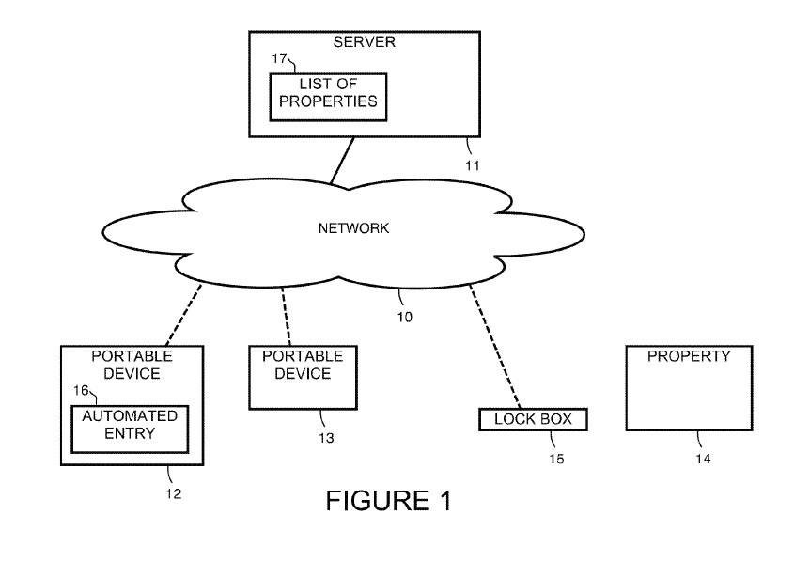
The specification further explains that “lock box 15” does, in fact, respond to time specific codes, and coordinates with the server database. For example, the specification states that “the server 11 communicates with lock box 15 to allow the visitor to enter during the specified time period and before the time of expiration.” Appx61, 8:5-7. There are additional disclosures throughout the specification explaining that the entry code which the lock box is able to respond to may be programmed to only function at a specific time. For example:
- “[A]uto-entry may be available only during specified hours.” Appx60, 5:36-37.
- “[A] property manager or owner or other keeper of the property sets viewing hours which are stored in server 11.” Appx60, 5:41-43.
- “Using the interface, an agent can enable a property for schedule showing during certain time periods.” Appx61, 8:55-56.
- “Using the interface, an agent can enable a property for schedule showing during certain time periods.” Appx61, 8:55-56.

In fact, the specification includes a clear example of one such code, demonstrating its time-specific nature. As can be seen in Figure 12 below, in one embodiment of the invention “a text message 95 [is] sent to a user that indicates a lock box code and a time of expiration.” Appx61, 8:2-3.
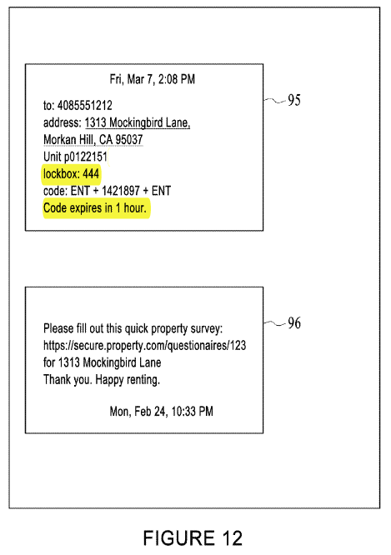
Appx53, ‘590 patent at Figure 12. In this example, the lock box that is placed at the rental property must be technology enabled and capable of coordinating with the server, because otherwise there would be no way for the lock box itself to know that code 1421897 will expire in one hour.
In short, it is simply not true that there is no support in the patent for the allegation of “technology enabled” in the amended complaint.
B. The Prosecution History Reveals Amendments Requiring a Lock Box Capable of Recognizing Time-Specified Codes.

It is also not true that during the prosecution of the ‘590 patent, the applicant overcame the examiner’s initial § 101 rejection with “the insignificant manual steps of placing the lock box or automated door lock and the visitor providing code information.” ECF No. 17 at 19. While Tenant Turner is correct that the examiner initially rejected claim 12 (which became claim 7) under § 101, the examiner rightfully withdrew that rejection after applicant amended the claim with a combination of elements that plainly required placement of an unconventional lock box.
As originally written, claim 12 required:
12. A computer implemented method for providing automated entry to properties, comprising:
making properties available for viewing;
receiving visitor requests to enter the properties;
providing automated entry information to the visitors that allows the visitors to enter the properties during specific times;
tracking visitor activities at the properties; and
making information about the properties available within a user interface.
See Appx173-174. Notably missing from this original claim is any mention of a lock box that is capable of opening in response to a code that is itself preconfigured to be valid for a predetermined period of time. As a result, the examiner rejected this claim as directed to non-statutory subject matter under §101 in light of Alice, in part because it did not recite any unconventional or non-generic structure that serves to perform the method. Appx156.
Rently’s responsive amendment was not to simply recite placement of a lock box. Rather, the amendment included, among other things, the addition of the requirement that the automated entry information is “code information that is valid during a specified period of time,” as well as the use of a lock box that “open[s] to facilitate automated entry” only “upon the visitor providing the code information to the lock box or automated door lock at the property within the specified period of time.” Appx173-174 (emphasis added). A full recitation of the amendment is included below:
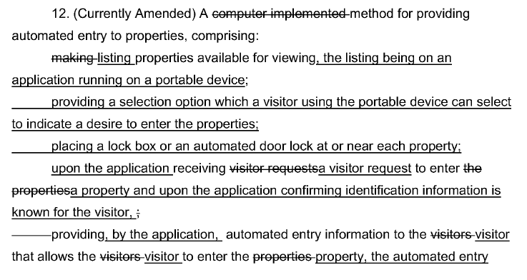
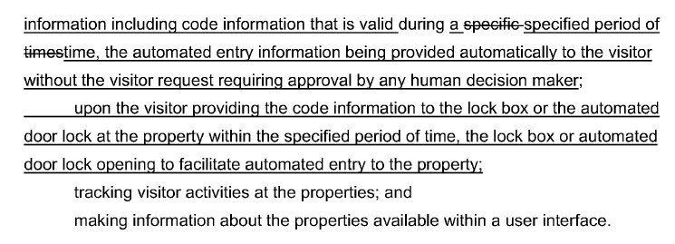
Id. The applicant argued that the claim, as amended, “sets out that upon the visitor providing the code information to the lock box within the specified period of time, the lock box or automated door lock opens to facilitate automated entry to the property.” Appx176. Thus, in responding to the examiner’s §101 rejection, the applicant clearly amended the claim to require the use of a technology-enabled lock box that is capable of responding to unique, time-specific codes only during the predetermined period of time that the codes are configured to operate. This is far beyond the mere addition of a lock box at the property that is capable of responding to “code information” in general, as Tenant Turner asserts.
In fact, these amendments are precisely what Tenant Turner asserts is lacking from the claim – the use of an unconventional technology-enabled lock box. The examiner understood this, and rightfully withdrew its §101 rejection, explaining that “Applicant’s response by virtue of amendment to claims has overcome the Examiner’s rejection under 35 USC § 101.” Appx186.

III. ARGUMENT
Rather than address Rently’s specific assertions in this appeal, Tenant Turner does what it did in the district court; namely, over-generalize the invention, ignore the combination of elements in claim 7 and the description of those elements in the specification and file history, and label the lock box “conventional”, despite supported allegation to the contrary. For the reasons explained below, the decision must be reversed.
A. The District Court’s Misunderstanding of the Claimed Invention—Or At Least the Dispute Over the Claimed Invention—Requires Remand.

Hoodwinked by the same arguments Rently makes on appeal, the district court did not appreciate the true nature of the invention and the functionally-improved lock box recited in claim 7. This underlying error is made clear by the court’s acceptance of Tenant Turners’s argument that “real estate agents have used lock boxes to provide licensed real estate professionals access to properties for decades” (ECF No. 22 at 9), and is underscored by the district court’s admission that its decision was based on its familiarity with lock boxes in general, but “not anything automatic.” Appx396, 62:11-18. This failure to understand the true nature of claim 7 infected the entirety of its analysis. See, e.g., Appx9 (“This Court finds that the claims at issue are directed to an abstract idea. Distilled to its essence, the claims use generic computing devices and techniques to provide automated entry to a property.”); Appx18 (“[I]t is not evident from the ‘590 patent specification that there is any inventive feature used in an unconventional manner. Further, the Court finds nothing in the pleadings to fill the gap in the specifications.”); Appx30 (“Unfortunately for the Plaintiff, such improvements are simply not captured in the language of Claim 7.”)
On appeal, as it did in the district court, Tenant Turner ignores the combination of claim elements and specification disclosures and repeats its conclusory allegation that claim 7 does not claim a technology-enabled lock box. For example, in Tenant Turner’s statement of issue number 3, it asks “can characterizations of claim elements in an amended complaint create fact or claim construction issues when the characterizations are not supported by the claim language or the specification?” As set forth in the facts above, Tenant Turner’s premise is incorrect. There is ample support in the language of the claim, the specification and the file history, for the allegation in the amended complaint that the lock box of claim 7 is a “technology enabled” lock box.
Moreover, to the extent there are “gaps” in the patent specification (for example, no express statement in the specification that lock boxes capable of coordinating with servers and recognizing time-specified codes are “functionally-improved” and “unconventional”), this Court has held that these gaps can be filled by allegations in the pleadings. See
Aatrix Software, Inc. v. Green Shades Software, Inc., 882 F.3d 1121, 1128-30 (Fed. Cir. 2018). Tenant Turner’s response to this is to summarily contend “the few facts that were new [in the amended complaint] raised no factual disputes or claim construction issues.” ECF No. 17 at 24. Yet, the nature and unconventionality of the claimed lock box’s functionality necessarily presents factual and/or claim construction dispute(s).
To the extent there is any factual dispute about whether the “lock box” of claim 7 is a technology-enabled lock box capable of recognizing a coordinated set of time dependent access codes that facilitate entry to a specific property by an invited visitor only during the pre-authorized period of time, as opposed to a conventional lock box that only responds to static, non-time-dependent codes, this Court must still reverse the district court’s decision. Such an analysis requires a weighing of competing claim constructions and cannot be made adverse to the patentee on a motion to dismiss. See MyMail, Ltd. v. ooVoo, LLC, IAC Search & Media, Inc., No. 2018-1758, 2019 WL 3850614, at *5 (Fed. Cir. Aug. 16, 2019) (vacating the district court’s decision that the asserted claims were unpatentable under §101 and holding that “the district court’s failure to address the parties’ claim construction dispute is [an] error under Aatrix.”);
Bascom Glob. Internet Servs., Inc. v. AT&T Mobility LLC , 827 F.3d 1341, 1352 (Fed. Cir. 2016) (explaining that at the 12(b)(6) stage, claim terms “must be” “construed in favor of [the non-movant].);
Content Extraction & Transmission LLC v. Wells Fargo Bank, Nat. Ass’n., 776 F.3d 1343, 1349 (Fed. Cir. 2014) (analyzing the patent eligibility of claims “when construed in a manner most favorable to” patentee.) This issue was brought to the district court’s attention numerous times during briefing and oral argument, and yet the court refused to adopt Rently’s proposed construction, or to institute any necessary claim construction proceedings.
Furthermore, Rently made this argument in its Opening Brief, and rather than addressing Rently’s arguments directly, Tenant Turner has simply stated that there is no legitimate claim construction dispute present because the claim language is allegedly “unambiguous” and Rently’s construction is therefore “[a]dvocative spin.” This is incorrect however, as explained thoroughly in Section II.A. and in Rently’s Opening Brief. The specification explicitly states that “the server 11 communicates with lockbox 15 to allow the visitor to enter during the specified time period and before the time of expiration.” Appx61, 8:5-7. Thus, even when used in the specification, the term “lock box” is defined as a technology-enabled lock box capable of coordinating with a server such that it can recognize and respond to unique time-specific entry codes (“automated entry information”). This is not mere “advocative spin” – it is the patentee’s own words used in the patent itself. Tenant Turner does not have the luxury of simply wishing away the plain language of the specification or a plausible (and Rently contends, correct) claim construction of a claim term advocated by the patentee.
Tenant Turner has failed to offer any support for its argument that claim construction is unnecessary. That Tenant Turner disagrees with Rently’s proposed construction is precisely why claim construction is required. Either there is a claim construction dispute (warranting reversal), or the claim must be construed as encompassing a technology enabled lock box that can recognize automated entry information and thereby facilitate keyless entry by a visitor to a property during a specified period of time (also warranting reversal). Regardless of which position this Court takes on the issue, the district court’s decision to grant the motion to dismiss must be reversed. See MyMail, Ltd, 2019 WL 3850614 at *5.

B. The ’590 Patent Claims Patent Eligible Subject Matter.
Had the district court properly understood the technology claimed by claim 7, it would have been compelled to deny the motion to dismiss. Claim 7 is rooted in technology and is directed to a specific method for how to achieve automated entry to properties by lock box recognition of unique time, visitor, and property-specific automated entry information rather than just the result of gaining automated access to a property. ECF No. 15 at Section II.A. Furthermore, the elements of the claim, particularly the requirement for a technology-enabled lock box synced and functioning as in the claim, adds significantly more to the idea of automated entry generally. ECF No. 15 at Section II.B. While Tenant Turner has attempted to refute the arguments made by Rently in its Opening Brief, its arguments continue to be just as conclusory as those made before the district court, ignore key components of the claim, fail to account for the disclosures of the specification and Amended Complaint, and are contradicted by controlling case law. Appellee Tenant Turner has failed to demonstrate that claim 7 is patent ineligible under §101, and the district court’s decision should therefore be reversed.

1. Claim 7 Is Not Directed To an Abstract Idea.
In opposing Rently’s Opening Brief, Tenant Turner argued that claim 7 is written at a high level of abstraction, and that it “would be difficult to characterize the claims in the ’590 Patent at a higher level of abstraction than they are written.” ECF No. 17 at 26. In order to make such an assertion however, Tenant Turner ignores roughly 1/3 of the claim language, so as to improperly give the impression that the claim was result oriented, rather than focused on the specific means of accomplishing the result of automated, secure entry. This is the exact same mistake made by the district court when it analyzed the claim based solely on its preamble. See ECF No. 15 at Section II.A.1. Specifically, Tenant Turner’s Step One analysis focused on an analysis of elements two and four, while intentionally ignoring the remainder of the claim limitations. ECF No. 17 at 27-28. This reads out limitations explaining that the claimed method is to be accomplished through the use of “a lock box or an automated door lock” (element 3) that is capable of “facilitate[ing] automated entry to the property” upon the “visitor providing the code information to the lock box or automated door lock at the property within the specified period of time” (element 5). Appx62, ‘590 patent at 10:43-44, 51-55. As discussed above, these are critical portions of the claim which inherently require a functionally improved technology-enabled lock box integrated to a coordinated database of unique, time-dependent entry codes that is capable of facilitating entry into a specific property in response to a code input made during a pre-authorized time period, as opposed to a mere “generic hardware device[]” as asserted by Tenant Turner. (See supra at § II.A.) Tenant Turner’s assertion that claim 7 could not be written at a higher level of abstraction is ironic, in that in order to advance its argument, Tenant Turner did exactly that.
This Court has repeatedly cautioned against describing claims at too “high [of a] level of abstraction and untethered from the language of the claims,” as that will “all but ensure[] that the exceptions to §101 swallow the rule.”
Enfish, LLC v. Microsoft Corp., 822 F.3d 1327, 1337 (Fed. Cir. 2016). Rather, courts must be cognizant of the “specific requirements of the claims” when conducting the Step One analysis to “avoid oversimplifying” the claims and downplaying the invention.
McRO, Inc. v. Bandai Namco Games Am. Inc., 837 F.3d 1299, 1313 (Fed. Cir. 2016); see also Enfish, LLC, 822 F.3d at 1337. By ignoring key components of the claim, and instead rewriting it to fit its argument, Tenant Turner (as well as the district court) has described claim 7 at an impermissibly high level of abstraction. Claim 7 is “limited to rules with specific characteristics” which must not be ignored. See McRO, Inc., 837 F.3d at 1313. Tenant Turner’s assertion regarding certain hand chosen excerpts from the claim has no bearing on whether the claim overall is abstract, and this Court should therefore decline to entertain Tenant Turner’s gross oversimplification of the claimed invention.
Notably, Tenant Turner does not explain why claim 7 is allegedly results- oriented aside from the over-generalized characterization of the claim, nor does it provide any detailed assessment in that regard. This is because when analyzed in its entirety, it is clear that claim 7 is focused on a specific technique for accomplishing one secure method of automated entry rather than merely the result of automated entry itself. See ECF No. 15 at II.A. Technically, an application might be said to achieve the result of “automated entry” (as opposed to the unique method of automated entry claimed by the ’590 patent) by sending a non-durational static code to all visitors wishing to enter a property, and utilizing run-of-the mill lock boxes that would always open in response to the chosen code. Those visitors would then be able to enter the property on their own at any time, albeit not in a secure manner. But this is not what was envisioned by the ’590 patent, nor is it what is claimed in claim 7. Instead, claim 7 is focused on a particular manner in which to achieve automated entry efficiently and securely, using time-specified codes (“automated entry information”) recognizable by lock boxes that have been integrated to a server database of codes, thereby facilitating entry to a property only during the pre-authorized time period assigned to each code. See supra at § II.A. These concrete, specific steps avoid abstraction by providing the specificity required to limit the claim to a particular method of achieving the result, as opposed to a claim on the result itself. See
Ancora Tech., Inc. v. HTC Am. Inc., 908 F.3d 1343, 1349 (Fed. Cir. 2018); see also
DDR Holdings, LLC v. Hotels.com, L.P., 773 F.3d 1245, 1257-58 (Fed. Cir. 2014);
Uniloc USA, Inc. v. ADP, LLC, 772 F. App’x 890 (Fed. Cir. 2019). Even Tenant Turner acknowledges this crucial distinction, noting that courts should look at “whether the claims in the patent focus on a specific means or method, or are instead directed to a result.” ECF No. 17 at 25.
After devoting roughly 9 pages of its brief to analyzing Step One under an incorrect and truncated reading of claim 7, Tenant Turner includes a mere three sentences applying that test to an expanded reading of the claim. According to Tenant Turner, claim 7 is abstract even if the functionally improved lock box “were read into the claims,” because that “merely incorporates a standard analysis of data, which is a generic computer function.” ECF No. 17 at 32. This is the first time Tenant Turner has characterized the integration of database tables between server and lock box as being a "standard programming technique”. It bears repeating, this conclusory assertion just like all of Turner’s other conclusory assertions does not save the case from reversal.
Not only is it not the analysis engaged in by the district court, there is no support for the assertion. Indeed, the conclusory assertion is the full extent of Tenant Turner’s argument in this regard. Tenant Turner does not offer any analysis, case law support, or detailed reasoning other than its single conclusory sentence that the improved technology-enabled lock box “merely incorporates a standard analysis of data.” But claims that include an element that analyzes data are still patent eligible where the focus of the claim remains on the specific means of achieving a goal, rather than the goal itself. See Enfish, LLC, 822 F.3d at 1339. Thus, Tenant Turner’s single, conclusory statement in this regard fails to change the analysis in any meaningful way. Since claim 7 is directed to one specific method of achieving secure automated entry, rather than just the result of gaining automated entry, the district court erred in finding the claim abstract and this Court should reverse its decision.

2. The Claimed Technology-Enabled Lock Box Was Unconventional At the Time of Filing.
Even if this Court were to determine that claim 7 is directed to an abstract idea, it is still patent-eligible because it contains inventive concepts sufficient to ensure that the patented invention amounts to “significantly more” than a patent on the alleged abstract idea itself.
See, Alice Corp. Pty. Ltd. v. CLS Bank Int’l, 134 S.Ct. 2347, 2355 (2014). In addition to the other inventive concepts described in detail in Rently’s Opening Brief, the use of the claimed technology-enabled lock box adds an inventive step because such a lock box was unconventional, non-routine, and not well-understood at the time of filing.
Preliminarily, there can be no doubt that claim 7 does, in fact, require a technology-enabled lockbox whose database table has been integrated with the server’s database table, thereby opening in response to the input of a unique durational code that has been preconfigured to be valid only during a predetermined period of time. See supra at § II.A. Thus, the only remaining question is whether such a specialized version of a technology-enabled lockbox is conventional. The district court did not address this specific question, since it misunderstood the claim as not requiring such a functionally-improved lockbox. But the amended complaint alleges that it is unconventional, and at the pleading stage this should be taken as true as a matter of law.
On appeal Tenant Turner never directly asserts that a lock box as described in Section I.A. of Rently’s Opening Brief is conventional. Instead, it more generally argues that the lockbox required by the claim was “well-known” and “generic”, without explaining whether this refers to the specific lockbox required by a proper construction of claim 7, or some other lockbox. ECF No. 17 at 6, 34, 37. Specifically, Tenant Turner argues that claim 7 and the disclosure of the specification do not require anything “beyond what was available in the prior art.” ECF No. 17 at 32. Tenant Turner further argues that “the ’590 Patent does not disclose or suggest that any specialized lock box is required beyond generic lock boxes that were available at the time of filing.” ECF No. 17 at 31 (emphasis added). These arguments – which are contrary to the pleadings which must be accepted as true—do not save this case from reversal.
First, the question at Step Two of Alice is whether the claimed feature is well-known, routine, or conventional, not whether it existed in the prior art at all.
Exergen Corp. v. Kaz USA, Inc., 725 F. App’x 959, 965 (Fed. Cir. 2018). However, “[s]omething is not well-understood, routine, and conventional merely because it is disclosed in a prior art reference.” Id. Finding otherwise would conflate the requirements for the conditions for patentability under 35 U.S.C. §§ 102-103 with the subject matter eligibility requirements of 35 U.S.C. § 101. Tenant Turner’s argument in this regard is therefore misguided.
Second, Tenant Turner has failed to account for the disclosure in the Amended Complaint. Tenant Turner argued below that claim 7 of the ’590 patent fails to meet the requirements of Alice Step 2 because “the ’590 Patent” itself does not disclose or suggest that the required lockbox is “specialized” or anything other than a “generic lock box[].” ECF No. 17 at 32 (emphasis added). But a patent specification does not need to explicitly state that a feature is unconventional in order for the patentee to make such an argument. A patentee is permitted to rely on assertions in its complaint to fill any gaps in the specification regarding the unconventional nature of the claims, as long as those unconventional features are encompassed by the claims themselves. See, e.g.,
Cellspin Soft, Inc. v. Fitbit, Inc., 927 F.3d 1306, 1317 (Fed. Cir. 2019); Aatrix Software, Inc., 882 F.3d at 1128-30. The Amended Complaint pleads the technology enabled lock box of claim 7 is “unconventional.” This should be the end of it at the pleading stage.
Tenant Turner’s flawed reasoning is the same mistake made by the district court in Cellspin that resulted in the reversal of its decision to grant a motion to dismiss. There, the patentee’s complaint contained “specific, plausible factual allegations about why aspects of its claimed inventions were not conventional.” Cellspin Soft, Inc., 927 F.3d at 1317-18. The district court discounted these allegations, explaining that Cellspin had failed to cite any support in the specification for its assertion that the claimed invention was unconventional. Id. The Federal Circuit disagreed with the district court’s reasoning, explaining that “[a]s long as what makes the claims inventive is recited by the claims, the specification need not expressly list all the reasons why this claimed structure is unconventional.” Id. Since the complaint included “specific, plausible factual allegations about why aspects of its claimed inventions were not conventional” this Court held that it could not conclude that the asserted claims lack an inventive concept at the motion to dismiss stage, and the district court therefore erred in granting the motion to dismiss. Id. at 1318-19.
Here, as in Cellspin, Rently has included specific, plausible, and concrete factual allegations as to the unconventional nature of the claimed invention. Rently’s Amended Complaint thoroughly explains, among other things, that the specific type of technology-enabled lockbox required by claim 7 was neither well-known, routine, nor conventional at the time the application was filed. For example, the Amended Complaint explains that “[w]ith the server and lockbox databases coordinated by identical code-time specifications that have been reconciled with schedule timelines preset to the property and the visitor’s availability, the ‘590 Patent improved the operation of the lockbox by enabling time, property, and visitor-dependent entry. This improved functionality was manifested by the lockbox only allowing entry in response to the unique durational code (“AEI”) that was issued to each visitor to a specific property at a specific time.” Appx409 at ¶ 26. The Amended Complaint further explains that “[a] generic lockbox could not enable ‘automated entry’ into a property under Claim 7 because it has not been integrated with the application’s server, it could only recognize static codes and not automated entry information, and it therefore would not be able to perform the very specific filtering function ‘to facilitate automated entry to the property.’ Therefore, the functionally-improved lockbox described in Claim 7 is neither a generic lockbox nor just a generic computing device.” Appx409 at ¶ 26. This is just one of the many examples in the Amended Complaint describing the unconventional, non-routine, and not well-understood nature of the claimed method. Thus, not only does claim 7 require a functionally improved technology-enabled lockbox, but Rently’s Amended Complaint has asserted that such a lockbox was unconventional at the time of filing. It was therefore not necessary for the patent specification itself to include statements in that regard, and any assertion to the contrary by Tenant Turner is legally incorrect. See, e.g., Cellspin Soft, Inc., 927 F.3d at 1317; Aatrix Software, Inc., 882 F.3d at 1128-30.
While the Court “need not accept as true allegations that contradict matters subject to judicial notice . . . such as the claims and the patent specification,” absent such an admission in the patent, there is no legal basis to affirm the dismissal of a complaint that contains plausible allegations that aspects of the claims are unconventional. See
Aatrix Software, Inc. v. Green Shades Software, Inc., 890 F.3d 1354, 1358 (Fed. Cir. 2018). Here, Tenant Turner has not pointed to anything in the specification or the claims contradicting Rently’s assertion in this regard – because there are no such contradictory statements. At no point does the specification of the ’590 patent describe the claimed lockbox as conventional, well-known, or routine. Rather, the specification describes the lockboxes used pursuant to the claim as being specifically adapted to their system, and thus not merely a lockbox that a user could purchase on their own at a store. This can be seen in Figure 14 and the accompanying description, which lists the lockboxes that are “available” for use if a property owner wishes to enable self-showing. As noted in the specification, Figure 14 (shown below) includes “Area 107,” which “sets out lockboxes available to be used by the owner for various properties.” Appx61, ‘590 patent at 8:34, 40-42.
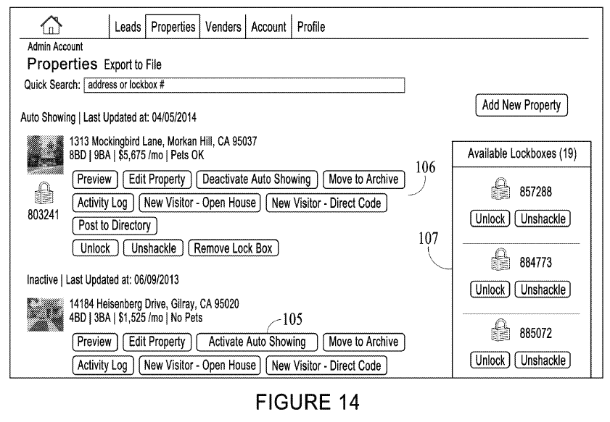

Furthermore, as discussed above (at Sec. III A, fn. 1, supra), the specification of the ‘590 Patent discloses the technological nature of the claimed lockbox.
Despite Tenant Turner’s repeated conclusory assertions that the claimed lockbox was “well-known,” “generic,” and “available,” it failed to cite to any evidence from the patent or complaint in support of its position. ECF No. 17 at 6, 34, 37. In fact, Tenant Turner has failed to offer any evidence in support of its argument at all, irrespective of whether such factually-sensitive claims could properly be weighed against the assertions in the Amended Complaint on a motion to dismiss.
Therefore, even if a fact-finder could ultimately determine that the claimed technology-enabled lockbox was conventional (and Rently asserts it cannot) such a determination cannot be made at this stage of the litigation. See
Nat. Alternatives Int’l, Inc. v. Creative Compounds, LLC, 918 F.3d 1338, 1347 (Fed. Cir. 2019). This Court recently addressed a similar situation in National Alternatives. There, the patentee appealed the district court’s decision to grant defendant’s motion for judgment on the pleadings under §101. The Federal Circuit reversed the district court’s findings due to allegations that the claimed method was unconventional. Id. Despite defendant’s argument that the specification counseled against such a determination, the Federal Circuit found that the language in the specification was insufficient to “establish that the dietary supplement in the claims . . . would have been well-understood, routine, and conventional.” Id. As explained by the court, “[w]hile a fact-finder may ultimately determine that the dietary supplement limitation was well-understood, routine, and conventional, absent a clear statement to that effect in the specification, complaint, or other material properly before the court, when disputed such a determination may not be made on a motion for judgment on the pleadings.” Id.
Tenant Turner’s citations to Quantum Stream, Solutran, Ultramercial, Electric Power, Content Extraction, and OIP do nothing to alter this analysis. Solutran and Electric Power were decided on summary judgment. See
Electric Power Group, LLC v. Alstom S.A., 830 F.3d 1350 (Fed. Cir. 2016);
Solutran, Inc. v. Elavon, Inc., 931 F.3d 1161, 1169 (Fed. Cir. 2019). There was no assertion in Ultramercial, Quantum Stream, or OIP that the components required to perform the claim were unconventional.
Ultramercial, Inc. v. Hulu, LLC, 772 F.3d 709 (Fed. Cir. 2014);
Quantum Stream Inc. v. Charter Commc'ns, Inc., 309 F. Supp. 3d 171 (S.D.N.Y. 2018);
OIP Techs., Inc. v. Amazon.com, Inc., 788 F.3d 1359 (Fed. Cir. 2015). And the patentee in Content Extraction conceded that the components were well-known. Content Extraction & Transmission LLC, 776 F.3d at 1348. Critically, here the conventionality of what is claimed is disputed. Claim 7 encompasses the improved technology-enabled lockbox, the Amended Complaint asserts that such a lock box was unconventional, and there are no admissions in the complaint or patent refuting these allegations. As a result, “there [is] no [] basis to affirm the dismissal of the complaint.” See Aatrix, 890 F.3d at 1358. Dismissal at the pleading stage, and denial of leave to amend, was improper.

IV. CONCLUSION
For the foregoing reasons, this Court should reverse the district court’s order dismissing Rently’s complaint and denying leave to file the Amended Complaint.
Dated: October 29, 2019 Respectfully submitted,

/s/ Rudolph A. Telscher, Jr.
Rudolph A. Telscher, Jr.
rudy.telscher@huschblackwell.com
Kara R. Fussner
kara.fussner@huschblackwell.com
HUSCH BLACKWELL LLP
190 Carondelet Plaza, Suite 600
St. Louis, MO 63105
(314) 480-1500
(314) 480-1505 Facsimile

Stephen Z. Vegh
svegh@veghlaw.com
VEGH IP LEGAL
1240 Rosecrans Ave., Suite 120
Manhattan Beach, CA 90266
(310) 980-7440
Attorneys for Appellant
Consumer 2.0, Inc., d/b/a/ Rently

CERTIFICATE OF COMPLIANCE
1. This brief complies with the type-volume limitation of Federal Circuit Rule 32(a) because this brief contains 6353 words, excluding the parts of the brief exempted by Federal Rule of Appellate Procedure 32(f).
2. This brief complies with the typeface and type style requirements of Federal Rule of Appellate Procedure 32(a)(5) and 32(a)(6) because this brief has been prepared in a proportionally spaced typeface using Microsoft Word 2010 in 14-point Times New Roman font.
/s/ Rudolph A. Telscher, Jr.
Counsel For Plaintiff-Appellant
Consumer 2.0, Inc. d/b/a Rently

CERTIFICATE OF SERVICE
I hereby certify that on October 29, 2019, I electronically filed the foregoing with the Clerk of the Court of the United States Court of Appeals for the Federal Circuit by using the CM/ECF system. Participants in the case who are registered CM/ECF users will be served by the CM/ECF system.

/s/ Rudolph A. Telscher, Jr.
Counsel For Plaintiff-Appellant
Consumer 2.0, Inc. d/b/a Rently

The disclosures in the specification also undermine Tenant Turner’s argument that the ’590 Patent “lacks any written descriptive support or an enabling disclosure for such a ‘technology-enabled’ lock box.” ECF No. 17 at 32. Turner’s argument is not germane to the current appeal, as the motion to dismiss was granted under 35 U.S.C. §101, not §112. Notwithstanding, the specification discloses the technological nature of the claimed lockbox. The application interface is able to retrieve from the server automated entry information from coordinated server and lockbox database tables. See Appx42-51, Appx58-61, ‘590 Patent, Fig. 1, Col. 2:41-50-Col. 5:19-20; Fig. 4, Col. 4: 2-6; Fig. 10, Col. 8:5-7. The valid code to gain entry to a specific property is communicated to the invited visitor’s portable device via the application interface from the server once the visitor has provided specific identifying information. See Appx42-51, Appx58-61 ,‘590 Patent, Fig. 1, Col. 2:55-59, Col. 3: 7-18, Col. 6:21-22, Col. 8: 1-5; Fig. 10, Col. 7:51-57, 63-67. The lockbox or similar locking device may then be opened to facilitate the automated and unaccompanied entry by the invited visitor during a specific period of time into a specific property. See Appx48, Appx60, ‘590 Patent, Fig. 7, Col. 5:26-30.
For example, Rently argued during the March 26, 2019 hearing on its Motion for Leave to file an Amended Complaint that the improved “lock box” operating under claim 7 is defined to “recognize only automated entry information,” that standard lock boxes could not recognize automated entry information, and therefore could not facilitate access to a property under claim 7. This improved functionality gave each invited visitor the ability to gain keyless entry to a property by themselves during a specified period of time. See Appx 571-573, 26:20-23, 27:17-21, 28:2-7, 10-15. The district court did not wish to receive additional briefing for a formal claim construction proceeding prior to ruling on whether the technology described in Claim 7 was conventional. See Appx 571-573, 19:2-6.
Nor should this Court credit Tenant Turner’s copyright argument. Not only does it suffer from the same flaw as the abstraction analysis (i.e., Tenant Turner ignores key portions of the claim), but copyright eligibility is analyzed under an entirely different standard and is not applicable to the current dispute.
Whether the integration of server and lock box database tables is a “standard programming technique” raises for the first time factual issues that are more the province of 35 U.S.C. §§ 102-103 than a subject matter eligibility evaluation under 35 U.S.C. § 101.
Tenant Turner occasionally makes statements about inventiveness (or asserted lack therof) of the ‘590 Patent as a whole, as opposed to just claim 7. See e.g., ECF No. 17 at 23 (“the '590 Patent does not contain any support for a functionally improved lockbox or any improvement in computing technology and computer science”) and at p. 28 (“there is no serious argument that Claim 7 (or any other claim in the '590 Patent) does anything to improve the functioning of a computer or to effect an improvement in any other technological field”). As correctly found by the district court, the only claim at issue is claim 7, because that was the only claim asserted.

